**CMSC203 Assignment 2 Implementation (Documentation)**

Class: CMSC203 CRN 21456

 Program: Assignment 2

Instructor: Dr. Ahmed Tarek

 Summary of Description: This is assignment is a random number guesser that tests upper and lower bounds.

 Due Date: 09/27/2021

 Integrity Pledge: I pledge that I have completed the programming assignment independently.

 I have not copied the code from a student or any source.

**Part1: Pseudo Code:** Here is a pseudo code for Assignment 2 program:

**Display a greeting and prompt the user for a number between 0 and 100.**

**Check user input to determine if user typed an integer.**

**If input is not an integer**

**Display error message for invalid input.**

**Else**

**Compare user input to the random number.**

**If the number is correct**

**Display message saying “Congratulations you guessed correctly. Try again? (yes or no)”**

**If user says yes**

**Restart Program**

**Else**

**end program**

**Else if the number is too high**

**Display message “Your guess is too high.”**

**Prompt user to enter a number between their guess and**

**the lower bounds**

**Else if the number is too low**

**Display message “Your guess is too low.”**

**Prompt user to enter a number between their guess and**

**the upper bounds**

**Part2: Comprehensive Test Plan**

A good test plan should be comprehensive. This means you should have a few test cases that test when the input is in and out of range, division by 0, incorrect Data type, etc. (Provide valid and invalid input)

|  |  |  |  |  |
| --- | --- | --- | --- | --- |
| Cases | Input | Expected Output | Actual Output | Did Test Pass? |
| Case 1 | 40 | You guessed correctly. It took you 1 tries. Play again? **yes** or no | You guessed correctly. It took you 1 tries. Play again? yes or no  **yes** | yes |
| Case 2 | 15 | You guessed correctly. It took you 1 tries. Play again? yes or **no** | You guessed correctly. It took you 1 tries. Play again? yes or **no** | yes |
| Case 3 |  |  |  |  |
| Case 4 |  |  |  |  |

**Part3: Screenshots related to the Test Plan:**

**Case 1**

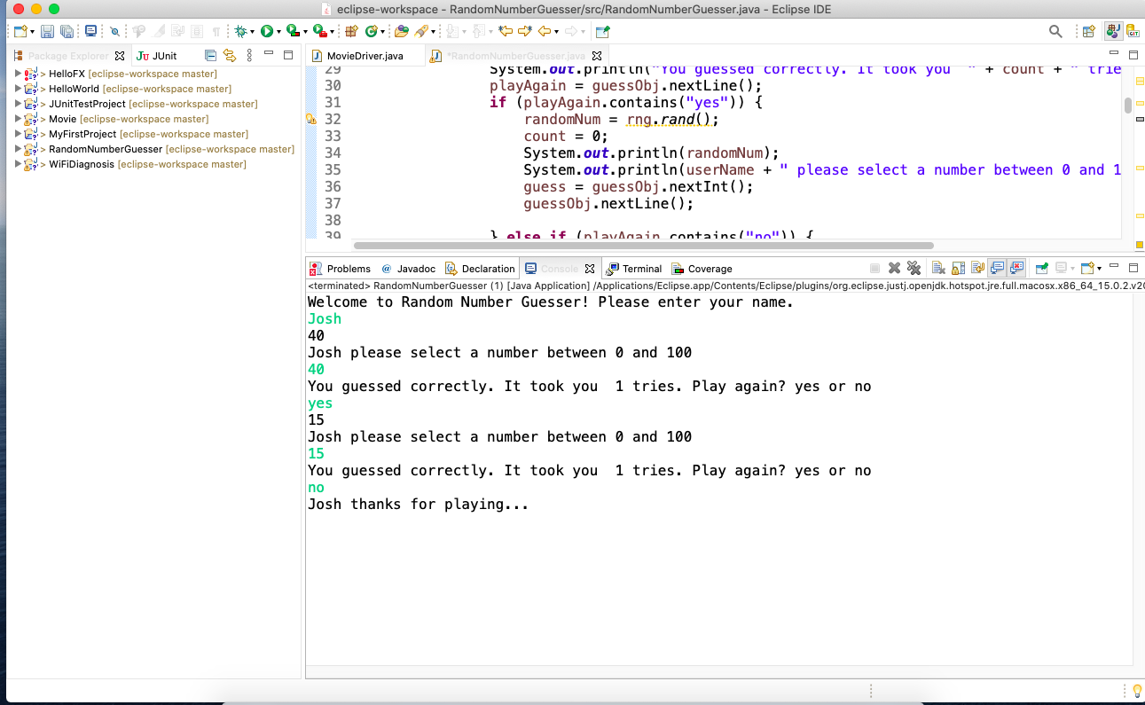

**Case 2**



**Case 3**

**Case 4**

**Lessons Learned** <Provide answers to the questions listed above>**:**

Write about your Learning Experience, highlighting your lessons learned and learning experience from working on this project.

What have you learned?

I learned that it’s better to breakdown nested if then statements. Control flow is really complicated at times.

What did you struggle with?

I struggled using the input validation from the RNG class.

What would you do differently on your next project?

I’d try to start small instead of trying to solve everything at once.

What parts of this assignment were you successful with, and what parts (if any) were you not successful with?

I was successful at solving the first iteration.

Provide any additional resources/links/videos you used to while working on this assignment/project.

n/a Only the Java Docs.

**Check List:** <Provide answers to the column Y/N or N/A >**:**

|  |  |  |  |
| --- | --- | --- | --- |
| **#** |  | **Y/N** | **Comments** |
|  | **Assignment files:** |  |  |
|  | * FirstInitialLastName_ Assignment#_Moss.zip | **Yes or No** |  |
|  | * FirstInitialLastName_Assignment#.docx/.pdf | **Yes or No** |  |
|  | * Source java files | **Yes or No** |  |
|  | **Program compiles** | **Yes or No** |  |
|  | **Program runs with desired outputs related to a Test Plan** | **Yes or No** |  |
|  | **Documentation file:** |  |  |
|  | * Comprehensive Test Plan | **Yes or No** |  |
|  | * Screenshots related to the Test Plan | **Yes or No** |  |
|  | * Screenshots of your GitHub account with submitted Assignment# (if required) | **Yes or No or N/A** |  |
|  | * UML Diagram (if required) | **Yes or No or N/A** |  |
|  | * Algorithms/Pseudocode (if required) | **Yes or No or N/A** |  |
|  | * Flowchart (if required) | **Yes or No or N/A** |  |
|  | * Lessons Learned | **Yes or No** |  |
|  | * Checklist is completed and included in the Documentation | **Yes or No** |  |

